***Directions: Provide a snippet of each figure in the tutorials below.***

**Tutorial 2-1 (Pg. 53):**

1. Figure 2-31:

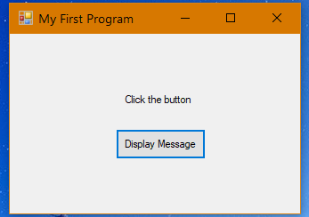

**Tutorial 2-2 (pg. 62):**

1. Figure 2-40:

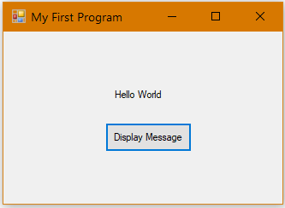

**Tutorial 2-3 (pg. 77):**

1. Figure 2-66:

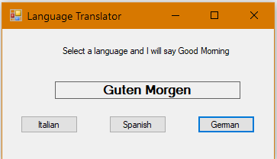

***Continuation of Snippets:***

**Tutorial 2-4 (pg. 84):**

1. Figure 2-75:

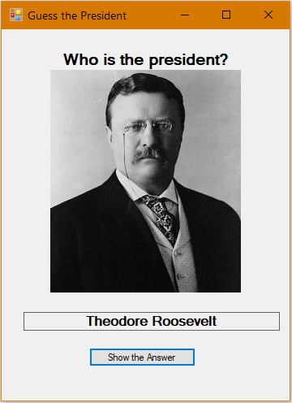

**Tutorial 2-5 (pg. 87):**

1. Figure 2-77:

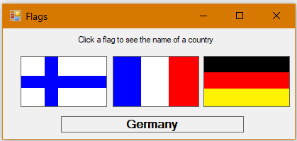

**Tutorial 2-6 (pg. 91):**

1. Step 6:

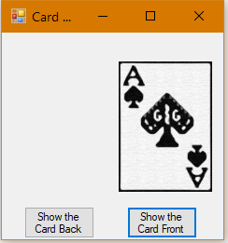

***Continuation of Snippets:***

**Tutorial 2-7 (pg. 95):**

1. Figure 2-84:

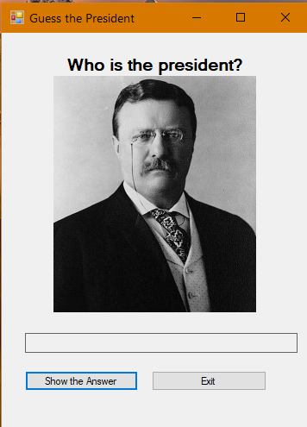

**Tutorial 2-8 (pg. 103):**

1. Figure 2-90:

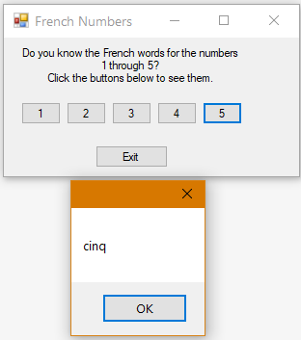

**Tutorial 2-9 (pg. 109):**

1. A snippet of the Lock Controls option:

